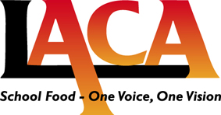
Tender for the Creation, Analysis and Delivery of an Annual Parent and Pupil Market Research of School Food.
LACA Ltd seeks to invite tenders from suitably experienced companies to deliver an annual survey aimed at parents and pupils. The form of questionnaire, with questions set by LACA, to be designed and the survey process carried out together with analysis and evaluation including publication of the results.
The process will take place over the coming few months and expressions of interest are sought in writing by Friday May 17th 2013.
Tender Process:
Tender documents will be sent out shortly after the above date, with a decision and award of contract in early July 2013. The survey to be carried out during September, with the outcomes published and launched in November at the time of National School Meals Week.
Expressions of Interest should be sent to Hilary Witt, Chair of Finance and Administration for LACA,
by email at hilary@laca.co.uk

