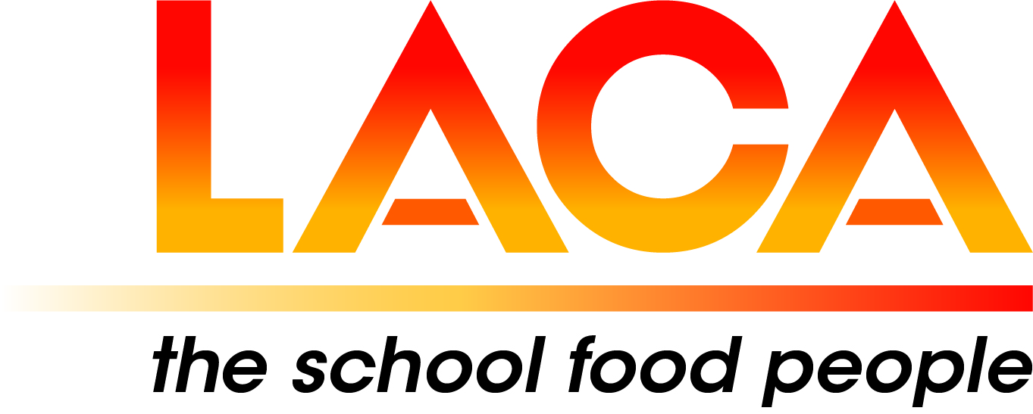

Date: 9 May 2022
Ref: LACA/KIH
Email: kathleen.hayton@ntlworld.com
Mobile: 07831 693385

West Midlands Region

Dear Colleague,

FREE EVENT – Thursday 9 June 2022

I refer to my email dated 12 April 2022 outlining the programme for the Meeting on 9 June 2022
and now confirm final details.

Venue
First Choice Group, Lakeside, Blakeney Way, Kingswood, Cannock. WS11 8LD.
Duration
1.30pm – 5.00pm. Afterwards at McArthurGlen Designer Outlet. WS11 7JZ
Car Parking
On entering the site, please drive to the end of the First Choice Building where there is a reserved area, outside the main entrance.

Programme

1.30 – 2.00 Arrival, Coffee, Tea, and Biscuits. Exhibition: First Choice, MKN and Fusion FSM.
2.00 – 2.10 Welcome: Lorna Hicks, Regional Chair.
2.10 – 2.40 Emotional Health and Wellbeing: How school caterers can support the work on mental health within schools: Sian Deane, Project Manager and School Improvement Adviser/ITT Lead/CPD Strategic Lead for the Shropshire and Telford Education Partnership Hub. Telford and Wrekin Council. Sian is a former Head Teacher.
2.40 – 3.25 Presentations: First Choice, MKN and Fusion FSM.
3.25 – 3.55 Exhibition and Networking, Coffee, Tea, and Biscuits.
3.55 – 4.05 SCOTY Regional Winner 2021: a brief report on the experience - Lee Taylor, Chef Manager, Atalian Servest.
4.05 - 4.25 Fruit in Schools Survey 2021: Mark Driver, Minor, Weir and Willis and kidsfruit.org. Supplier of fruit to 16,600 state schools in England with direct daily delivery to 7800 of them in 56 Local Authorities.
4.25 – 4.55 Over to you for discussion on ‘’Potential impact on the child’s plate of rising food costs and staffing shortages’’.
4.55 – 5.00 Close: Lorna Hicks
5.00 – Visit to McArthurGlen Designer Outlet, Eastern Way, Cannock WS11 7JZ: Meal at Five Guys and some Retail Therapy!
Booking (NB there is no separate Booking Form)
Please email Pat Hughes not later than Friday 27 May 2022. Please include your name, Local Authority/School/Company and telephone contact details.
Email: hughespatricia135@gmail.com

Diary Date
Thursday 19 July 2022
4.00pm Summer Riverside Walk (just under 4 miles) in Bridgnorth, followed by Indian Tapas at the Falcon Hotel.

I look forward to seeing you on 9 June when we have an opportunity for meeting in person once again.

Yours sincerely

Kath Hayton
Kath Hayton
Hon. Secretary

