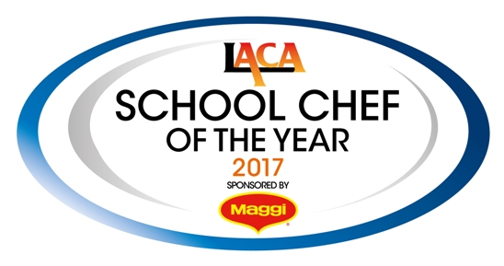

SCOTY 2017 - Entrant Details

Return this form along with the Main Course and Dessert Recipe & Costing Spreadsheets, the document giving the main course and dessert methods, allergen information and your Rule 11 explanation plus pictures of your dishes both on presentation plates and produced en masse to the SCOTY Competition Organiser no later than Friday 28th October 2016.

Please submit the full entry by email to scoty@dewberryredpoint.co.uk

If you have any questions on submitting your entry, please call the competition organisers on
0845 108 5504.

Name of Organisation
LACA Region
Manager’s Name
Telephone Number
Mobile Number
E-mail address
ENTRANT AND MENU DETAILS:

Contestant’s Name
Contestant’s age |  | Contestant’s Gender
Contact Number |  | this number will only be used in relation to the competition entry and not given out to media without prior permission

School Name
School Address
School Type | (Primary, Primary Academy, Secondary, Secondary Academy, Free School, Special School)

Main Course title

Dessert title
Please list the Maggi® and Nestlé® products used in your entrant’s recipes below:
NB: A minimum of one Maggi® or Nestlé® product must be used in both the main course and in the dessert. This must form a significant part of the recipe, not just used as a garnish.

Main Course

Dessert

If you held a local heat to determine your entrant, please give your other competitor’s names below as we will provide certificates of participation for all who enter the competition

