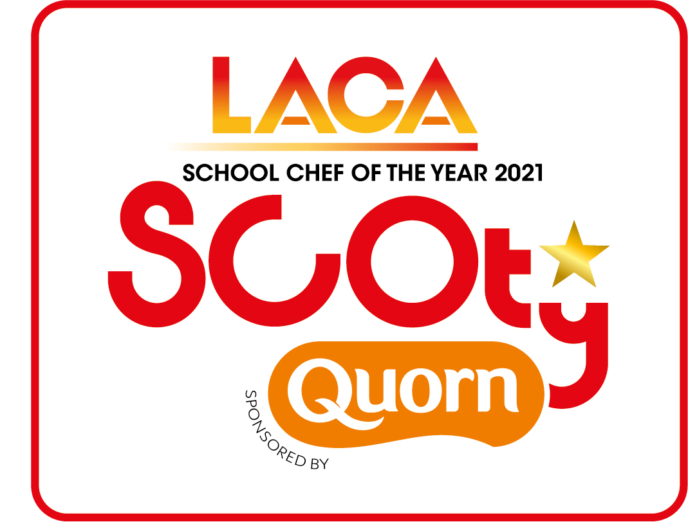

SCOTY 2021 - Entrant Details

Name of Organisation/School
LACA Region
Manager’s Name
(main point of contact for this entrant)
Telephone Number |  | Mobile Number
E-mail address
ENTRANT DETAILS:

Return this form along with the Main Course and Dessert Recipe & Costing Spreadsheets, the document giving the main course and dessert methods, the FSA allergen information tick list sheet and your Rule 11 explanation plus pictures of your dishes both on presentation plates and produced en masse to the SCOTY Competition Organiser no later than Friday 26th March 2021.
Please submit the full entry by email to scoty@dewberryredpoint.co.uk
If you have any questions on submitting your entry, please call the competition organisers on 0845 108 5504.

Contestant’s Name
Contestant’s age |  | Contestant’s Gender
Contact Number |  | this number will only be used in relation to the competition entry and not given out to media without prior permission

School Name
School Address

School Type
QUORN INGREDIENTS USED:
Please tick the Quorn products used in your entrant’s recipes below. A minimum of one different Quorn product from the core list must be used in the main course. This must form a significant part of the recipe.

CORE RANGE

Quorn Mince

Quorn Pieces

Quorn Fillet

Quorn Best of British Vegan Sausages

DELI RANGE

Quorn Vegan Chicken Free Slices

Quorn Vegan Smoky Ham Slices

