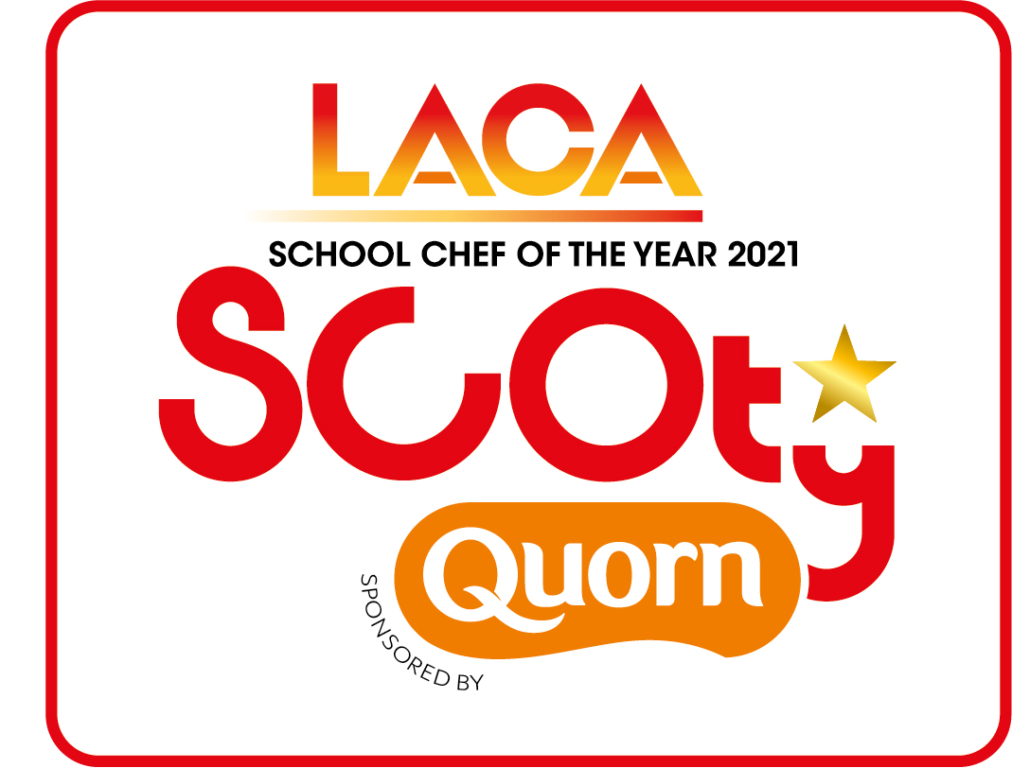

SCOTY 2021 –

Main Course and Dessert method
Rule 11 explanation of your menu

Name of Organisation/School |  | LACA Region
Entrant Name |  | School name
- This should give step by step instructions on how to create both dishes and clearly show the skills being used in the recipes – please use bullet points or numbers to show each step.
- Make sure to include oven temperatures and cooking times.
- Cross reference to make sure all ingredients are listed on the costing sheet and included in the method.
- Please list all allergen ingredients used in your recipes on the allergen chart included and submit with your entry forms.

Main Course method:

Dessert method:

Rule 11 explanation of your menu, to include:
- What inspired you to create the dishes?
- The reasoning behind the product application of the Quorn product/s you have used in your dishes
- What changes to the ingredients, method or skills would need to be made when the menu is produced en masse in your school environment?
- Where sustainable products or locally sourced ingredients have been used.

Maximum 150 words permitted. This information will be displayed on the photography table at the regional final and national final stages of the competition.

Submit this form along with your Entrant Details, the Main Course and Dessert Menu Recipe & Costing Sheets and the Allergen information

tick list sheet to the SCOTY Competition Organiser
NO LATER THAN FRIDAY 23RD APRIL 2021
By email to scoty@dewberryredpoint.co.uk

