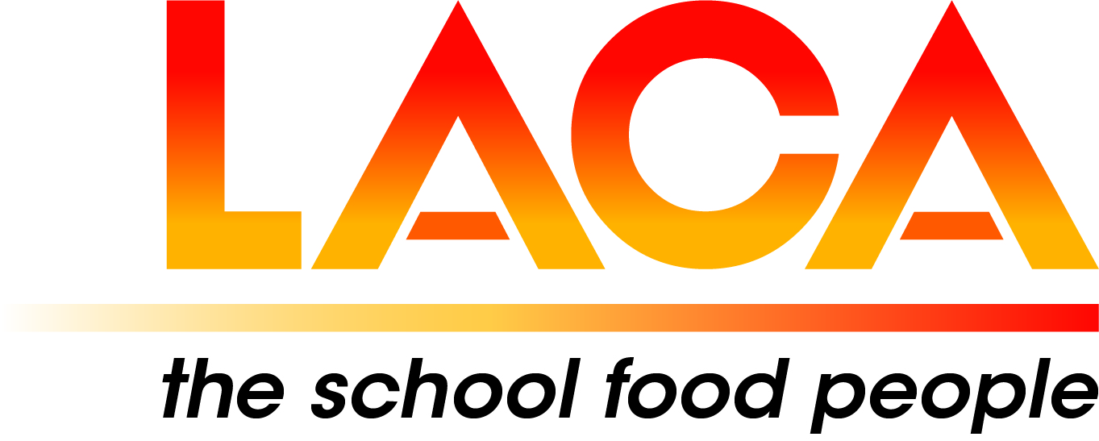

West Midlands Region

Annual General Meeting
Thursday 10 February 2022 via Microsoft Teams
Agenda

- Apologies

- Minutes of AGM on 11 February 2021

- Matters Arising

- Chair/ Vice Chair
At the AGM in 2021, Lorna Hicks was elected as Vice-Chair. It was agreed that
Jackie Foster should continue as Chair for a further year until the AGM 2022 when Lorna becomes
Chair. It was agreed at the Committee Meeting on 11 January 2022 that Jackie will be Vice-Chair.
The current Committee is due for re-election in 2023.

- LACA Board Report – Lorna Hicks

- Chair’s Report

7. Treasurer’s Report

8. Secretary’s Report

9. Updates, pre-posted member items

10. Future Programme

