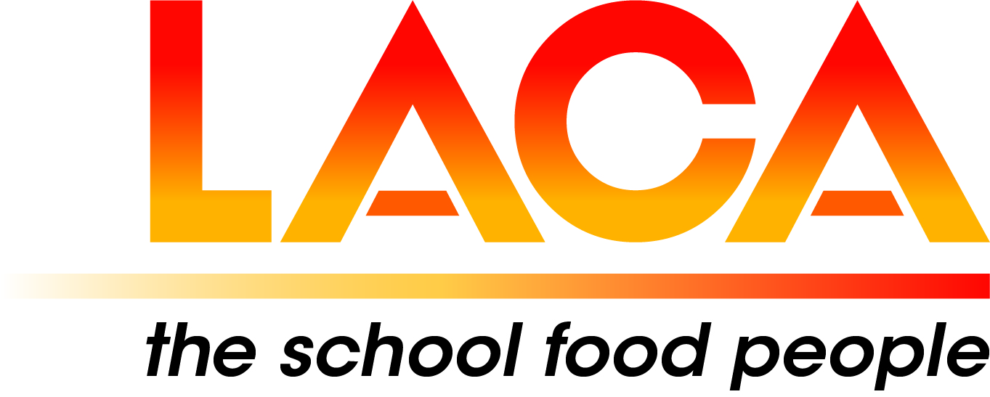

West Midlands Region

Annual General Meeting
Thursday 16 February 2023 via Microsoft Teams
Agenda

- Apologies

- Minutes of AGM on 10 February 2022

- Matters Arising

- Election of Committee 2023-2024 – Nominations are still required for Hon. Treasurer and Committee Members.

- LACA Board Report – Lorna Hicks

- Chair’s Report

7. Treasurer’s Report

8. Secretary’s Report

9. Updates, pre-posted member items

10. Future Programme

