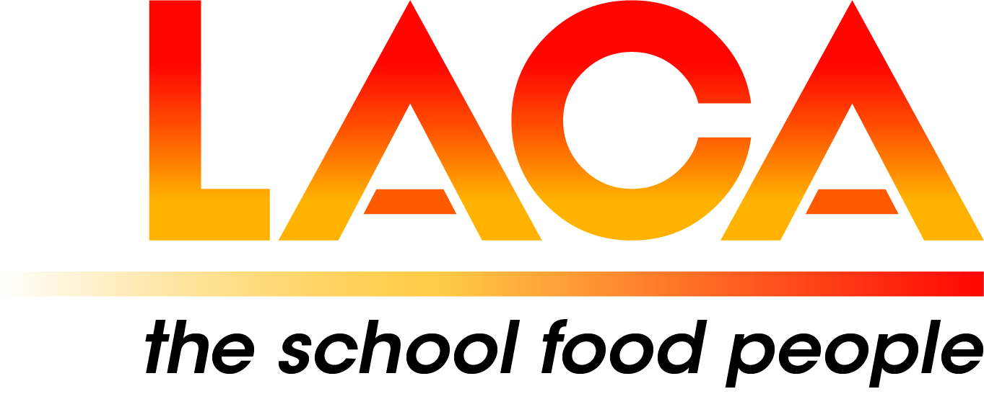

**West Midlands Region**

**Annual General Meeting**

**Thursday 27 February 2025 via Microsoft Teams**

**Agenda**

1. Apologies
2. Minutes of AGM on 8 February 2024.
3. Matters Arising
4. Committee 2024-2026
5. LACA Board Report – Lorna Hicks
6. Chair’s Report
7. Treasurer’s Report
8. Secretary’s Report
9. Updates, pre-posted member items.
10. Future Programme – Thursday, June 2025, via Microsoft Teams.

* Thursday, 16 October 2025, In-person.
* Your ideas for future programmes