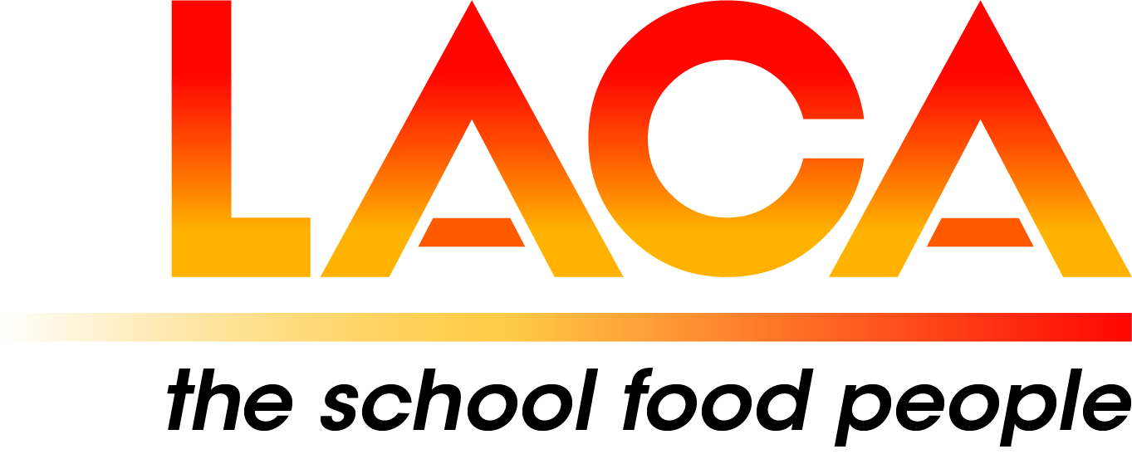

Date: 24 January 2025

Ref: LACA/KIH

Email: [kathleen.hayton@ntlworld.com](mailto:kathleen.hayton@ntlworld.com)

Mobile: 07831 693385

**West Midlands Region**

Dear Member,

**Regional Meeting & AGM on Thursday 27 February 2025 at 1.30pm via Microsoft Teams**

I refer to my email dated 14 January 2025 and now confirm the programme and booking details for the online Meeting on Thursday 27 February 2025 at 1.30pm via Microsoft Teams.

**Programme**

1.30pm Welcome – Lorna Hicks, Chair

1.40pm AGM – Agenda attached. If you wish to post any items for the agenda and/or have ideas for future programme/venues, please email me.

2.00pm ‘Food for Life Served Here’ - Sophie Pritchard, Head of Sustainable Catering, Soil Association

2.20pm LACA National Update - Judith Gregory, LACA National Chair. Judith will update members on LACA's campaign for fairer school meals funding and share the plans for 2025.

3.00pm ‘Technology in the Kitchen - Solihull Catering Services experience’ - Paul Wayman, Head of Catering Services, Solihull MBC.

3.20pm ‘My life at Hollinswood School’ - Kathy Dennis, Veteran Chef, Hollinswood Primary School, Telford & Wrekin Council.

3.40pm Questions

4.00pm Close.

To book a place, please email Jayne Hill, **not later than Friday 7 February 2025. Please include your name, Local Authority/School/Company, email address and contact details.**

**Email:**[**jhill@whmat.academy**](mailto:jhill@whmat.academy)**. *Lorna will send the Meeting Link a few days before the Meeting..***

I look forward to seeing you online on 27 February 2025, and especially welcome new Members.

**Diary Date:** Regional Meeting online on **Thursday 5 June 2025 at 1.30pm** via Microsoft Teams

Yours sincerely

*Kath Hayton*

Kath Hayton

Hon. Secretary