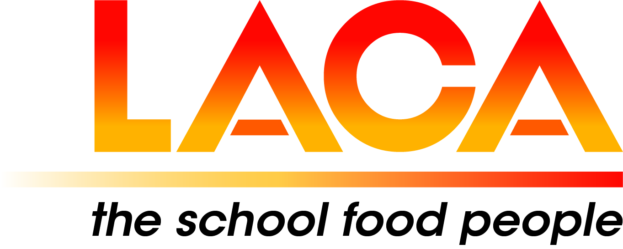

Date: 21 July 2022
Ref: LACA/KIH
Email: kathleen.hayton@ntlworld.com
Mobile: 07831 693385

West Midlands Region

Dear Member,

FREE EVENTS – Tuesday 27 September 2022 and Riverside Walk Tuesday 18 October 2022

Further to my email last week, I am now able to confirm final programme details for the above. This Event includes a Free Prize Draw for attendance: Day delegate place (Thursday), Awards Dinner, and overnight accommodation for the 2023 LACA Main Event, for a Member and Member colleague.

Venue
First Choice Group, Lakeside, Blakeney Way, Kingswood, Cannock. WS11 8LD.
Duration
1.30pm – 5.20pm. Afterwards at McArthurGlen Designer Outlet. WS11 7JZ
Car Parking
On entering the site, please drive to the end of the First Choice Building where there is a reserved area, outside the main entrance.

Programme

1.30 – 2.00 Arrival, Coffee, Tea and Biscuits. Exhibition – Fusion FSM, First Choice and MKN.

2.00 – 2.10 Welcome – Lorna Hicks, Regional Chair.

2.10 – 2.40 Emotional Health and Wellbeing: Sian Deane, Project Manager and School Improvement Adviser/ITT Lead/CPD Strategic Lead for the Shropshire and Telford Education Partnership Hub. Telford and Wrekin Council.

2.40 – 3.25 Presentations: First Choice, MKN and Fusion FSM.

3.25 – 3.55 Exhibition and Networking, Coffee, Tea and Biscuits.

3.55 – 4.25 SCOTY, Regional Winner 2021: Lee Taylor, Chef Manager, Atalian Servest. Lee will speak about the experience and will demonstrate his plant-based ‘Grab and Go’ dish from the competition.

4.25 - 4.45 Fruit in Schools Survey 2021: Mark Driver, Minor, Weir and Willis and kidsfruit.org. Supplier of fruit and direct delivery to 7800 Schools in 56 Local Authorities.

4.45 – 5.15 "Potential impact on the child's plate of rising food costs" followed by discussion:
Brad Pearce, LACA National Chair. This will be via Microsoft Teams.

5.15 – 5.20 Close – Lorna Hicks

5.20 – Visit to McArthurGlen Designer Outlet, Eastern Way, Cannock WS11 7JZ
Meal at Five Guys/ Retail Therapy.

Booking (NB there is no separate Booking Form)
Please email Pat Hughes not later than Friday 26 August 2022. Please include your name, Local Authority/School/Company and telephone contact details.
Email: hughespatricia135@gmail.com

Tuesday 18 October 2022

3.30pm Riverside Walk (just under 4 miles) in Bridgnorth, followed by Indian Tapas at the Falcon Hotel.

This event on 19 July 2022 was postponed following a hot weather warning, which proved to be the "the hottest day on record in the UK".

Meet at The Falcon Hotel, St John's Street, Bridgnorth. WV15 6AG to be ready to commence the Walk at 3.30pm.
Car Parking at the adjacent Pay and Display.
The circular walk will take approximately two hours and will be followed by Indian Tapas at the Hotel.
Please email Pat to book - details as above.

I look forward to seeing you on 27 September and 18 October 2022.

Yours sincerely

Kath Hayton
Kath Hayton
Hon. Secretary

