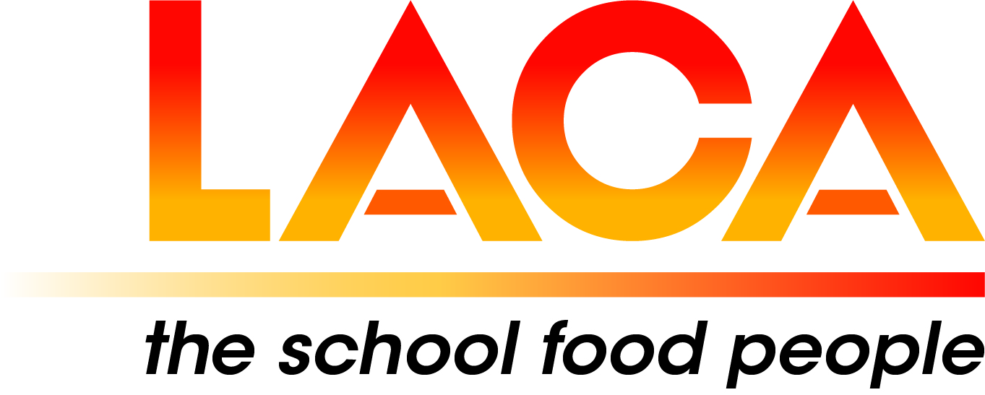

Date: 14 October 2021
Ref: LACA/KIH
Email: kathleen.hayton@ntlworld.com
Mobile: 07831 693385

West Midlands Region

Dear Colleague,

FREE EVENT - Tuesday 2 November 2021
Sustainability Part 2

I refer to my email dated 1 October 2021 advising you of our first in person Meeting on
Tuesday, 2 November 2021 and am now able to confirm final details of the programme.

Venue
Oakengates Theatre (The Place)
19 Limes Road,
Oakengates
Telford. TF2 6EP
Duration
9.30am – 3.00pm
Car Parking
At the Theatre.

Covid Safety

Please bring either proof of double vaccination – NHS Covid Pass or a recent negative lateral flow test.

Please do not attend if you have any coronavirus symptoms or have been instructed to self-isolate.

Use of face masks is advised.

Programme

09.30 - 10.00 Arrival, Tea and Coffee

10.00 - 10.15 Welcome from Jackie Foster, Chair, West Midlands Region

10.15 - 11.00 Children’s Panel – Hollinswood Primary School (and Nursery) - Sustainable Journey.
Including Video presentations.

11.00 – 11.20 Planning to focus on how Telford & Wrekin Council Catering plays a central role in the
Council’s priorities and touching on what has been done in the last few months – Fliss Mercer, Director, Telford and Wrekin
Presentation to Lorna and Kate, Catering and Cleaning Green Innovation Award APSE.

11.20 – 11.40 LACA Buying Group/TUCO frameworks - Hannah Myton-Wright, Category Manager
TUCO Ltd, including presentation from Blakemore Foodservice.

11.40 – 12.00 Presentation - Miami Burger, sustainability - Jonathan Holden, Managing Director,
CARU Brands Ltd

12.00 - 12.20 Presentation - Emma Patch and Cheryl Farmer - Quorn Foods.

12.20 - 12.40 Presentation - Plant based products - Patrick Millington, Unilever.

12.45 - 13.30 Lunch

13.30 - 13.50 LACA Update - Brad Pearce, newly appointed LACA National Vice-Chair. This Presentation will be virtual.

13.50 – 15.00 Regional updates - Over to you - Members, Partners and Associate Members.

Booking (NB there is no separate Booking Form)
Please email Pat Hughes not later than Friday 22 October 2021. Please include your name, Local Authority/School/Company, telephone contact details and any special dietary requirements.

No bookings can be received after this date, as in the spirit of the theme we need to avoid food waste.
Email: hughespatricia135@gmail.com

Diary Dates

Wednesday 9 February 2022 - AGM
Thursday 2 June 2022
I look forward to meeting with you on 2 November 2021.

Yours sincerely

Kath Hayton
Kath Hayton
Hon. Secretary

