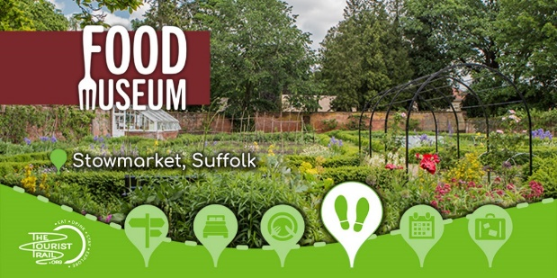

**East of England Regional Event and AGM**

**The Food Museum, Stowmarket**

**9.30am-3pm,**

**Thursday 5 th June 2025**

**Agenda**

**Welcome and National Update from National Vice Chair Micheal Hales**

**Allergen Challenges Presented by Mike Travis, School Grid**

**Daily operational challenges faced by our catering team Presented by Tom Frost Aspens**

**Balancing Nutrition and Budget Presented by John Want HCL**

**SCOTY – Q&A with Carol Harwood LACA Lead for Scoty joined by our regional competitors**

**Plus a Tour of School Food exhibition**

**During the day there will be the opportunity to network and chat to our supporting suppliers.**

**Refreshments and Lunch will be provided along with charity raffle**

**We look forward to welcoming you all on the day**