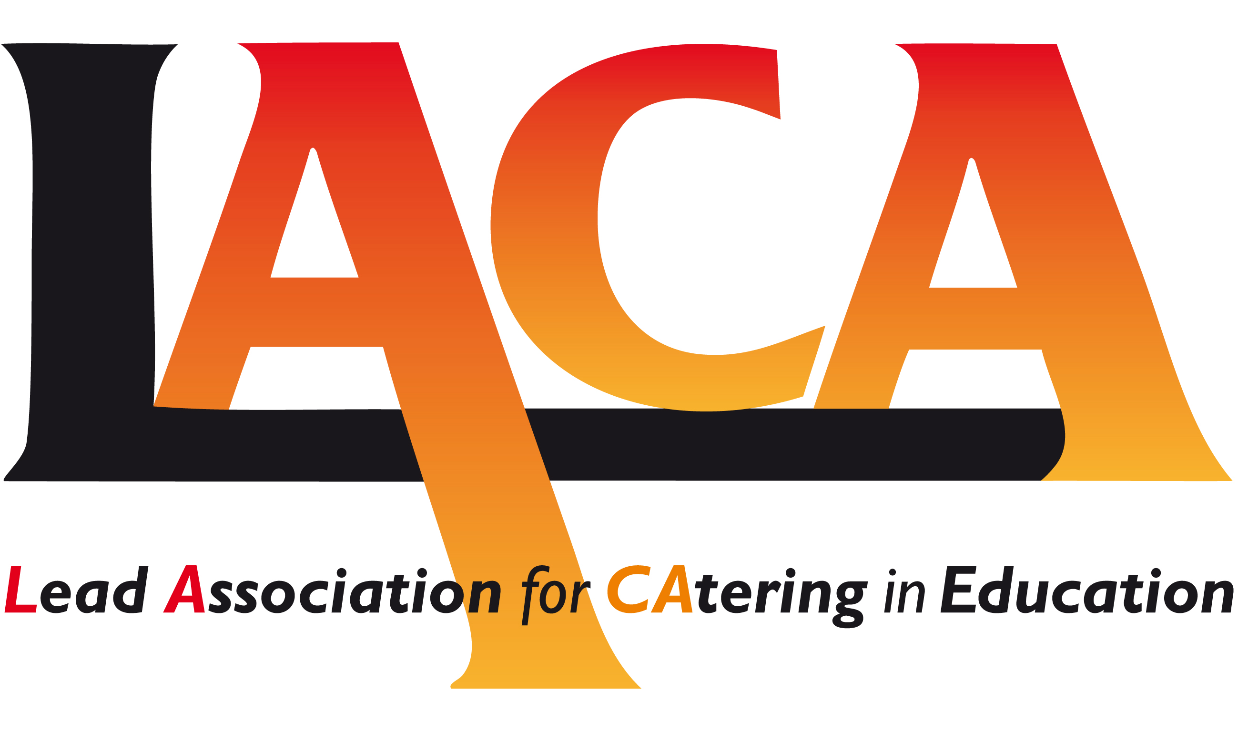

Date: 28 March 2019
Ref: LACA/KIH
Email: kathleen.hayton@ntlworld.com

West Midlands Region

Mobile: 07831 693385

Dear Colleague,
***FREE EVENT***

Seminar Thursday 6 June 2019
Hillstone Primary School, Hillstone Road, Shard End, Birmingham. B34 7PY

I refer to my email dated 12 March 2019 and now confirm the programme for the Seminar on
Thursday 6 June 2019. Following the success of last year’s Event, the Seminar will once again be held at Hillstone Primary School, Birmingham, by kind permission of Gill Sparrow, Head Teacher.

The School is within easy access of the M6/M42. Parking on site is limited. Street parking is available. It would be helpful to car share where possible. The nearest Rail Stations are Lea Hall.

Hillstone Primary is a Multi Award winning School including Bronze Food for Life and since our last visit, has achieved two more Awards - LACA Self-Delivered/In House Catering Operation Award 2018 and EDUcatering Self-Managed School Caterer of the Year Award 2018. I am also pleased to advise you that the School and Matthew have been shortlisted in two categories - Education and Chef, for the forthcoming Cost Sector Catering Awards in April 2019.

The programme includes the following:

- Update from Hillstone Primary School
- FEED – Feeding Excellence Every Day
- Sustainable Food in Schools: an appetite for change?
- Update on Juniper Ventures Ltd and LACA
- School Plates – How small changes can make a difference
- Exhibition and Networking
- Barbecue

2.00 pm Arrival, Tea, Coffee and Biscuits. Exhibition viewing and networking.
Exhibitors – Magic Breakfast, FareShare and Food for Life.

2.45 pm Welcome - Jackie Foster, Chair, LACA West Midlands Region.

2.50 pm Dining @Hillstone - The smart choice for lunch and more. An update on the Multi-Award
Winning School. The whole school approach to food in school and the community –
Gill Sparrow, Head Teacher and Matthew Knight, Catering Manager.

3.05 pm FEED – Feeding Excellence Every Day – an approach for school pupils which focuses on
making every service moment at lunch as good as it can be, starting with looking at the
dining environment through the eyes of pupils – Steve Kemp, Divisional Director, ISS.

3.30 pm Sustainable food in schools: an appetite for change? – Isabelle Kelly, Sustainability Projects
Officer, Quorn Foods.

3.50 pm Exhibition viewing and networking.

4.20 pm The first year of trading at Juniper Ventures Ltd (London Borough of Newham)
- Michael Hales, Managing Director
LACA update– Michael Hales, LACA National Chair

4.50 pm School Plates – How small changes can make a difference to children’s health, the planet,
and save you money - ProVeg International.

5.05 pm Charity Raffle – proceeds for The Stroke Association and The Children’s Cancer and
Leukaemia Group.

5.15 pm Comfort Break and Allotment viewing.

5.30 pm Barbecue in the Allotment space. Approx. finish time 6.30pm.

Booking Form

Booking Form attached. Please email to Pat Hughes not later than Friday, 26 April 2019.
Email: pathughes@educaterers.co.uk
Tel: 01926 412999 or 07717 891072

Diary Dates for Regional Events

Thursday, 3 October 2019 at Digbeth Dining Club (on trend Street Food) Birmingham commencing at 2.30 pm and including a presentation from one of the Traders
Thursday 13 February 2020 AGM – Stoke College TBA
Thursday 4 June 2020 - TBA

What would you as a Member, like to see included in these Events? The Committee very much welcome your suggestions - please advise me by email.

I look forward to meeting with you on 6 June 2019.

Yours sincerely

Kath Hayton

Kath Hayton
Hon. Secretary

